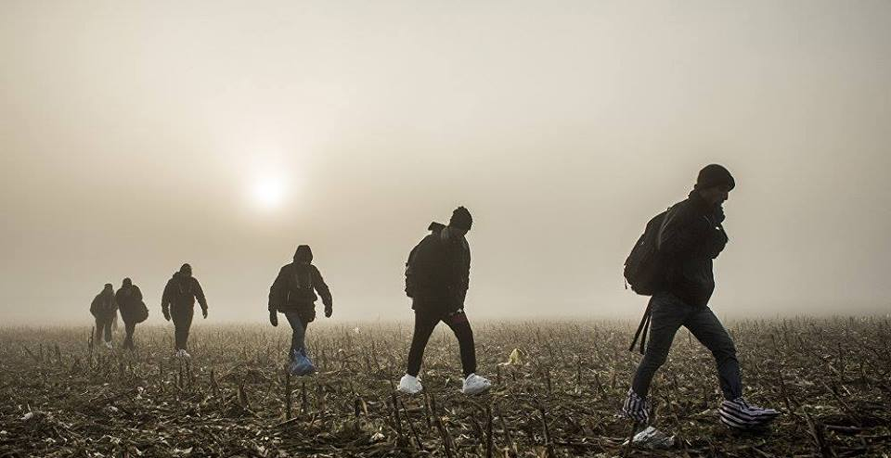
From “Crisis” to Challenges of Integration
The Current State of the Balkan Migration Route
A Conference of the MIGRATE : CTRL + EnterEurope Jean Monnet Migrant Crisis Network

Date: 5 December, 2016
Venue: Nador 15 Building, Room 103

Program:
8:30 Registration
9:00 Opening remarks
- Péter Balázs, Director, CEU Center for European Neighborhood Studies
- Alexandra Prodromidou, MIGRATE Academic Coordinator, South-East European Project Center
9:20 Panel I: The Refugee Issue after the Closing of the „Balkan Route”
- Dimitris Tsarouhas, Associate Professor, Department of International Relations, Bilkent University
- Pavlos Gkasis, South-East European Project Center
- Zoran Ilievski, University of Cyril and Methodius
- Jovan Teokarevic, Professor, Faculty of Political Sciences, University of Belgrade
Moderator: AlHakam Shaar, Fellow, Shattuck Center on Negotiation and Recovery
11:10 Panel II: Destination Countries on the Migration Crisis
- Marko Kmezic, Lecturer, Senior Researcher, University of Graz
- Christina Krause (tbc), Konrad Adenauer Stiftung, Germany
- Francesca Strumia, Lecturer in Law, University of Sheffield
Moderator: Dimitris Keridis, Director, Navarino Network
14:00 Panel III: Hungarian Policymakers on the Refugee Issue
- Tamás Csiki, Assistant Research Fellow, Center for Strategic and Defense Studies, National University of Public Service
- Aranka Lőrincz, Appointed Director for Refugee Affairs, Office of Immigration and Nationality
- Balázs Orbán, Director General, Migration Research Institute
Moderator: Péter Balázs, Director, CENS
15:50 Panel IV: Civil Society, the Migration Crisis and the Challenge of Integration
- András Kováts, Menedék – Hungarian Association for Migrants
- Prem Kumar Rajaram, CEU OLIve – The Open Learning Initiative
- Salome Schaerer, Felix Bender, MIGSZOL
- Eszter Kósa, SOS Children's Villages International, Hungary
Moderator: Bogdan Mihail Radu, Visiting Researcher, CENS
17:20 Closing Remarks
RSVP: szalaia@ceu.edu

